


Technical Tip 38

ESTOS setup with SMS Comfort

ESTOS ProCall is a Unified Communication solution that includes Telephony Integration, Presence Management and Instant Messaging.
With SMS comfort it is very easy to integrand SMS notification in to ESTOS

Preparing: SMScomfort and Estos

Install SMS comfort and Estos

For more info about Estos go to http://www.estos.com

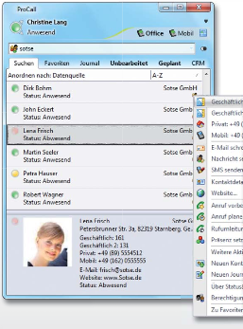

Step 1: create the smsprovider.xml for Estos.

Create a file smsprovider.xml in C:\Program Files\ESTOS\CtiServer\config\
for your sms comfort settings.

If sms comfort is running on another server as the ESTOS server you need to change localhost to the IP address from SMS comfort. Copy the XML script and past this in the empty smsprovider.xml file.

File content:

<?xml version="1.0" encoding="utf-8"?>
<smsproviderlist>
<smsprovider name="www.smscomfort.eu">
<serverurl>http://localhost:22281/smsin/smsin.asp</serverurl>
<services>
<service name="SMS Comfort">
<description>SMS Comfort is a local SMS gatwaye application installed on a local server. </description>
<parameter>senderID=%SMSSENDERNR%&amp;gsmnr=%SMSRECIPIENTNR%&amp;msgcontent=%SMSMESSAGE%</parameter>
</service>
</services>
<method>get</method>
<messageencoding>plain</messageencoding>
<usernameencoding>plain</usernameencoding>
<passwordencoding>plain</passwordencoding>
<successcodes>
<code description="Accepted">0</code>
</successcodes>
<errorcodes>
<code description="No Local Account">1000</code>
<code description="No Mobile Account">1001</code>
<code description="Duplicate Alias">1002</code>
<code description="Not Sent To Net">1003</code>
<code description="Invalid To Hdr">1004</code>
<code description="Message Too Long">1005</code>
<code description="BlackList">1006</code>
<code description="WhiteList">1007</code>
<code description="Month Limit">1008</code>
<code description="Week Limit">1009</code>
<code description="Day Limit">1010</code>
<code description="No Permission">1011</code>
<code description="GroupNotExists">1012</code>
<code description="TooManyEmailClients">1013</code>
<code description="Account Disabled">1014</code>
<code description="Wrong To Header">1015</code>
<code description="Route Not Found">1016</code>
<code description="Invalid Delay">1017</code>
</errorcodes>
</smsprovider>
</smsproviderlist>

Step 2: Setup sms dispatch.

Select SMS Service Provider from the list.
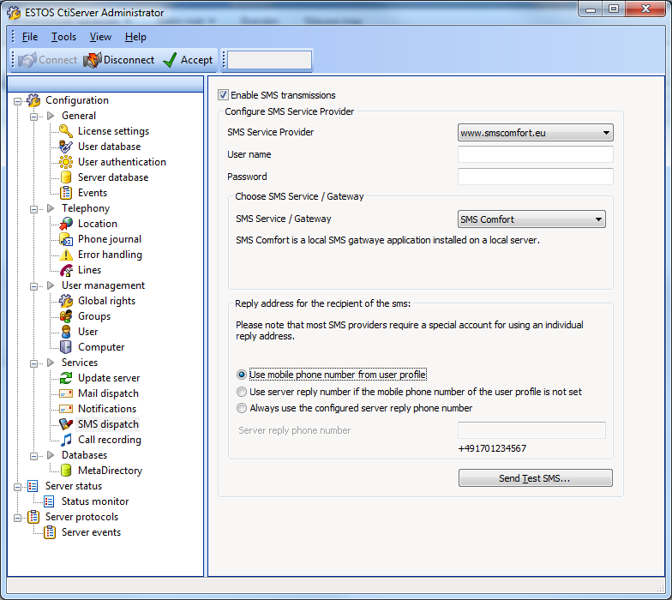

Step 3: Setup SMS comfort User for Estos.

In SMS comfort GUI go to Manager Email and select or create the user.
Using SMS comfort integration with Estos you need to add a sender ID in the user account. In case of Estos this will be the Mobile number from the user.

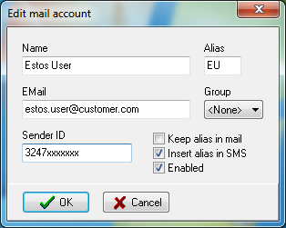
Name: username
Alias: mostly the initials from the user.
Email: the email address from the user
Sender ID: the user mobile number known in Estos.

This is not automatically generated but can by imported
via an CSV import. (for more info go to SMS comfort help)

Step 4: Test SMS from SMS Dispatch.

Press the button on the SMS dispatch page. “Send Test SMS....”

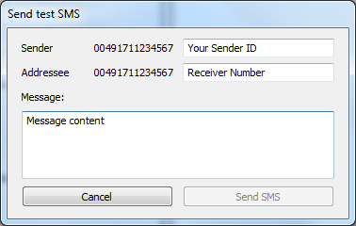
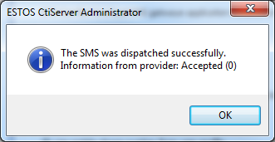

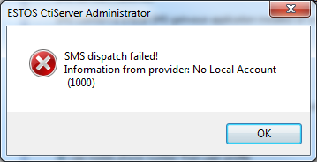

Reply on SMS messages will be sent to the user mailbox.

