

Connecsy 6.0
Installation Checklist

Version : 1.0
Status: Final

On site needs

Below settings need to be ready before going onsite
- PC’s with O.S. operational with installer permissions
- Callback extension ready
- Attendant settings ready
- Network for the Connecsy PC ready
- Avaya eConsole License installed (CM 5 = SAP order ID 174066 and CM 6 = SAP order ID 228931)
- When using the advanced Busy Lamp Features, the Avaya Communication Manager SNMP agent needs to be accessible.
- Excel file with contactinformation for the telephone directory

Network

Quality Of Service:

Connecsy 6.0 supports Quality of Service.
To guarantee the quality of the of the softphone, we recommend to enable QoS on the network.

Full Duplex:

Almost every network card into a PC is set to auto-negotiate the speed and duplex settings.
In most circumstances the pc or switchport will lock to 100MB Half Duplex.
This will have a lot of problems in case there is heavy voice traffic to and from the Connecsy.
In that case the Connecsy is not be able to answer or transfer the calls.
This can be easily changed by setting the switchport and PC network card fixed at
100 MB Full Duplex

Settings from Avaya Communication Manager

The items below need to be available before going on site.

- IP addresses of CLAN boards on which Connecsy might connect.
Think about load balancing your available CLANs
- In case of LSP we need the LSP IP address
- Number blocks on the attendant console for the
BLF’s (Busy Lamp Fields)
- The extension number including the security code of the attendant console
- The callback extension number
(This is the phone which is used for the Connecsy speech path)
- IP address of the communication manager server for the SNMP client

4. Phonebook Directory inventarisation

Connecsy is having the ability to manage a phonebook database.
By default it’s using the SQL database.
It is also possible to use a Firebird database. This option is integrated in the installation.
Before going on site we need to have a Excel or CSV formatted file with customer details
to import it into the SQL database.
You can import the CSV file manually or automatically. It is also possible to connect to a LDAP store
The LDAP is an optional module of Connecsy

Het CSV Format needs to be like this:

0 | 1 | 2 | 3 | 4 | 5 | 6 | 7 | 8 | 9 | 10 | 11
Extension | Name | Surname | Department | Office | mobiel | Private | Pager | Car

The Column headers need to be imported

Example import file
0; 1; 2; 3; 4; 5; 6; 7; 8; 9; 10; 11
extension;name;surname;department;office;mobile;private;pager;car;;;;

Default Connecsy settings for the Avaya Attendant Console

In below screenshot you can see the default connecsy feature button settings

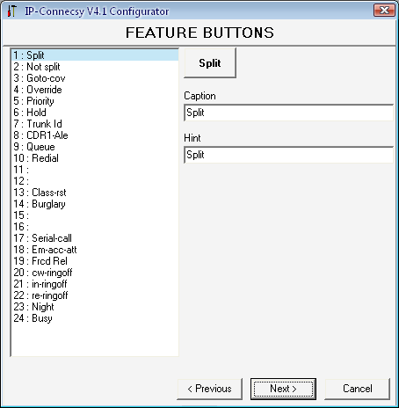

In the next screenshot you can see how to setup the default Connecsy feature buttons into the Avaya. In case of using non default settings you have to tell us what the changes are.
A screenshot of the attendant form would be enough for us.

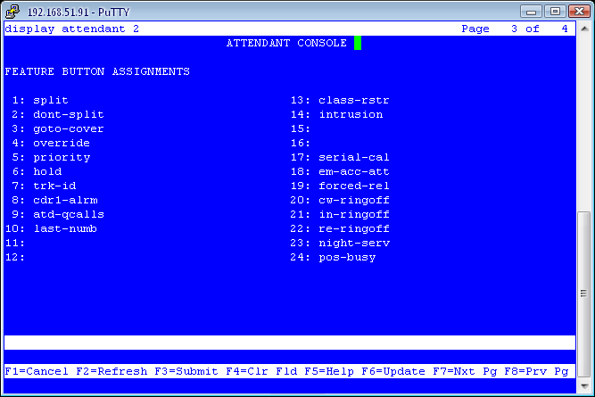

Database information

In the installation wizard you can choose for an SQL (Express) database or a firebird database. This information has to be known in advance.

When an MS SQL database will be used, the next information had to be known:

- SQL Server
- SQL User
- SQL Password

Connecsy Configuration information

- There had to be known if there has to be dialed an extra number for outbound & internal dialing.

- When using 1 of more queues, the queue information has to be known. Like the position of the queue & the queue name.

- When the Calendar-integration will be used, the account of the Connecsy user needs to get read-policies on the calendars of all employers and one of the supported applications has to be installed & configured.

- When the LDAP module is purchased, there has to be known if the Connecsy user may write in the Active Directory. Also known which fields this user can modify. This user has to get the rights before.

- The order of the information fields has to be known.

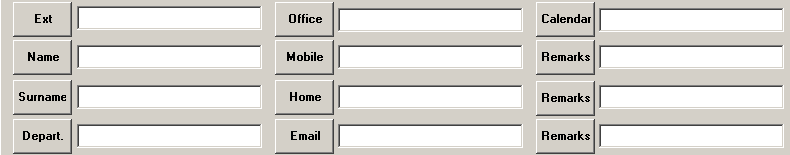

The default order is:

- Extension 7. Home
- Name 8. E-Mail
- Surname 9. Calendar
- Department 10. Remarks
- Office 11. Remarks
- Mobile 12. Remarks

If the names of the information fields had to be modified in order or from name, then this has to be known before the installation.
Example: ‘Extension’ has to be modified in ‘Telephone’, or one of the remark fields has to be modified in ‘License plate’.

8 Connecsy PC requirements

The minimum hardware specifications of the Connecsy are:
- Windows XP SP3 (There is no Lync integration possible on Windows XP).
- Windows Vista of Windows 7 (also 64-bit)
- P4 processor or higher.
- 1024 MB internal memory.
- A minimum of 500 MB free harddisk space.
- Networkcard 100/1000 MB Full duplex (10MB is not enough)
- 1 COM-port when using a Callmaster VI phone.
- USB port when using a USB Headset.

At least .NET framework 3.5 and the latest version of DirectX need to be installed. For the Lync integration you need .NET framework 4.5..

PC Screensaver and automatic standby mode must be disabled!

Note:
Pridis cannot guarantee the functionality of Connecsy when using other application on the system.

Checklist Delete as applicable

The next database will be used Firebird / SQL
(Please fill in the information below when using an SQL Database)

SQL Server
SQL User
SQL Password

There has to be dialed an extra 0 for outbound dialing? Yes / No
There has to be dialed an extra 0 for internal dialing? Yes / No

How many queues has to be configured? 0 / 1 / 2 / 3

The calendar integration will be used? Yes / No
(When using the calendar integration, please select the using application below)

Lotus Notes

Microsoft Office Outlook 2003
Microsoft Office Outlook 2007
Microsoft Office Outlook 2010
Microsoft Office Outlook 2013

PBX Informatie
IP Adress PBX
Ip Adress LSP (Optional)
Ip Adress LSP (Optional)
Ip Adress LSP (Optional)
Attendant Extension
Attendant password
Callback Extension

Other information to be submitted:
- Import-CSV file for telephone directory -chapter 4
- Order of the feature buttons - chapter 5
- To be configured BLF groups (optional)
- Order of the information fields (optional) - chapter 7

